UNIT 1

Computer Applications

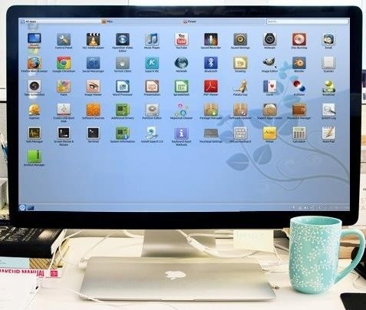

Picture 1.1

**Learning Outcomes**:

By the end of the lesson, the students are expected to be able to use appropriate English to:

* identify kinds of computer applications and their potential users
* identify and use Simple Present Tense for explaining their activities
* identify and use imperatives and sequencer in a text
* explain how to install a computer application using imperatives and sequencers

# Kinds of computer applications and its potential users.

**Exercise 1**: Look at the following set of pictures on computer applications. Complete the table. Try to predict who is going to use each of the programs. An example has been given for you.

* + 1. Adobe Premiere Pro b. Blender

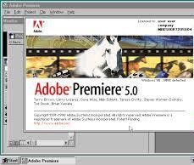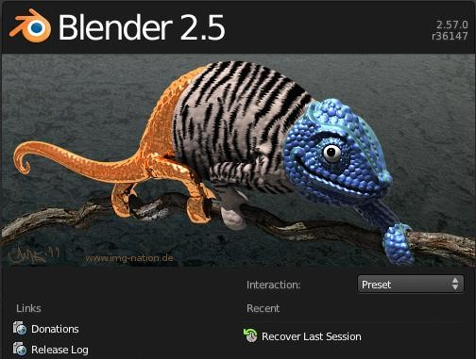

Picture 1.2 Picture 1.3

c. Cash Register d. Google Earth

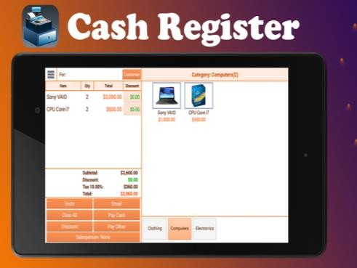

Picture 1.4 Picture 1.5

e. PrognoCIS f. VSCO

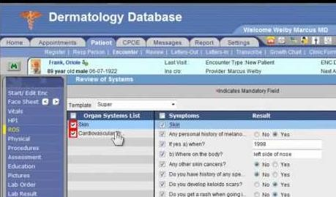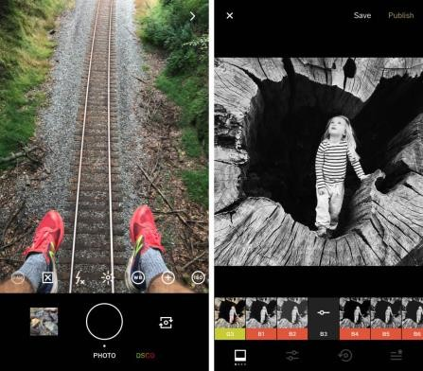

Picture 1.6 Picture 1.7

|  |  |  |  |
| --- | --- | --- | --- |
| **No.** | **Name of Applications** | **Uses** | **Potential Users** |
| **a.** | Adobe Premiere | * to edit videos * To create project music * To create project film * To create video documentation | * student * content creator * video editor |
| **b.** | Blender | To create animation film  To create visual effect  To create 3d model | Student  Animator |
| **c.** | Cash Register | To calculate and record sales report  Logs transactions that occur in your store, creating a record of the money coming in and going out. | Cashier  Manager cashier |
| **d.** | Google Earth | Visualize and analyze satellite images of our planet. | Traveller  Scientist  Geographer  Crimatology  People who want earth virtually |
| **e.** | PrognoCIS | System management | Doctor  Dermatologist |
| **f.** | Vsco | To edit photos | Phothographer  Editor  Content Creator |

**Exercise 2**: Listen to four people talking about how they use computers at work. Complete the

table while listening and choose each of the speaker’s job from the box below.

electrical engineer

secretary

librarian

composer

|  |  |  |
| --- | --- | --- |
| **Speakers** | **Job** | **What they use computers for** |
| **1.** | composer | Keyboard connected to the computer, stores all the effect and synths.make and record the music |
| **2.** | secretary | Writing memos, emails, faxes and contacting offices overseas |
| **3.** | Electrical engineer | Calculate how many wattage does a room need, how long a cable should be. To draw a rough design or a prototype of a room’s electrical wiring., |
| **4.** | Librarian | Classified and categorized dvd, magazines, and also stores all password. To easily find a spesific book in the library, also to print and use fax. |

**Exercise 3:** Think and decide what computer application each of the speakers is used to help

his/her work

|  |  |
| --- | --- |
| **Speakers** | **Computer Applications They are likely Used** |
| **1.** | Abelton, FL studio, Apple Logic Pro, Notion 6, Muscore |
| **2.** | Microsof Word, Google docs, Gmail, Yahoo! Mail |
| **3.** | AutoCAD |
| **4.** | Library Application |

**Exercise 4**: Read the text about *The Digital Age* carefully, then discuss with your partner about

“How people nowadays use computers”.

|  |  |  |
| --- | --- | --- |
|  | The Digital Age |  |
|  |  |  |
| We are now living in what some people call the digital age, meaning that computers have become an essential part of our lives. Young people who have grown up with PCs and mobile phones are often called the digital generation. Computers help students to **perform** mathematical operations and improve their mathematics skills. They are used to access the internet to do basic research and communicate with other students around the world. Teachers use projectors and interactive whiteboards to give presentations and teach sciences, history, or language courses. PCs are also used for administrative purposes - schools use **word processors** to write letters, and database to keep records of students and teachers. A school website allows teachers to publish exercises for students to complete **online**. Students can also enroll for courses via the website and parents can **download** official reports.  Mobiles let you make video calls, send texts, email people and download logos, ringtones or games. With a **built-in** camera you can send pictures and make video calls in face-to-face mode. New smartphones combine a telephone with web access, video, a game console, an MP3 player, a personal **digital** assistant (PDA) and a GPS navigation system, all in one.  In banks, computers **store** information about money held by each customer and enable staff to access large databases and to carry out **financial** transactions at high speed. They also control the cashpoints, or ATMs (Automatic Teller Machines) which dispense money to customers by the use of a PIN-protected card. People use a chip and PIN card to pay for goods and services. Instead of using a signature to verify payments. customers are asked to enter a four-digit personal identification number (PIN), the same number used at cashpoints, this system makes transactions more secure. With online banking, clients can easily pay bills and transfer money from the comfort of their homes.  Airline pilots use computers to help them control the plane. For example, **monitor**s display **data** about fuel consumption and weather conditions. In airport control towers, computers are used to manage radar systems and regulate air traffic. On the ground, airlines are connected to travel agencies by computer. Travel agents use computers to find out about the availability of flights, prices, times, stopovers, and many other details.  *Infotech English for Computer Users (2011: 2-3)* | | |

**Exercise 5**: Match the words in column A (1-10) with their meanings in column B (a-j).

|  |  |
| --- | --- |
| 1. perform b | a. keep, save |
| 2. word processor i | b. execute, do |
| 3. online f | c. monetary |
| 4. download a | d. screen |
| 5. built-in e | e. integrated |
| 6. digital | f. connected to the internet |
| 7. store | g. collection of facts and figures |
| 8. financial c | h. describes information |
| 9. monitor d | i. program used for text manipulation |
| 10. data g | j. copy files from a server to your PC or mobile |

**Exercise 6**: Go back to Exercise 4. Look at the text. The underlined sentences that are written in

simple present tense. When you are talking about facts or routine, you use present simple tense. Look at the examples below:

**Computers help** students to perform mathematical operations and improve their mathematics

skills.

**Teachers use** projectors and interactive whiteboards to give presentations and teach sciences,

history, or language courses**.**

**A school website allows** teachers to publish exercises for students to complete online.

English for Informatics 1: Seventh Edition

*Can you find more sentences using this tense? Write them down here:*

Look at the explanation about Simple Present Tense:

|  |  |
| --- | --- |
| The present tense is the **base form** of the verb  But the third person (she/he/it) adds an ***-s*** | * I **work** in a multimedia company. * She **works** in a multimedia company. |

We use Simple Present Tense to talk about:

|  |  |
| --- | --- |
| 1. something that is true in the **present** | * He **studies** C++ language programming this semester. * I**’m** an Information Technology   student. |
| *2.* something that **happens again and again** in the present or **routine**  We use words like **sometimes, often, always**, and **never** (adverbs of frequency) with the present  tense | * I **play** online games every weekend. * I **sometimes** play online games with my friends. * She **never** plays online games. |
| 3. something that is **always true** or  **facts** | * Light **travels** at almost 300,000   kilometers per second. |

|  |  |
| --- | --- |
| 4. something that is **fixed** in the future | * The school term **starts** next week. * The train **leaves** at 09.45 this evening. * We **have** a test next week. |

**Exercise 7**: Use present simple to write sentences that describes four different functions of

present simple tense.

**Exercise 8**: Write down how you use your computer to help you both study and do your hobbies

or free-time activities.

**On my free time I use computer to**

**However, when I study I use computer to**

* 1. **Sequencing in giving instruction on how to install a computer software application. Exercise 9**: Have you ever installed a program in your computer? What are they? Do you have difficulties? How do you solve the problems?

**Exercise 10**: Study these instructions on how to format a computer and install Windows. Pay attention to the *italic* and underline words.



When you want to format and install Windows 10 on your PC, what you need to prepare is Windows 10 installation disc. Make sure that it is original one since you need a serial number or a product key to complete the installation process. Moreover, you need to follow these following steps. *First*, insert the Windows 10 installation disc in your computer and restart the computer. When the prompt appears, press any key on your keyboard to begin the installation process during the boot procedure. *Second*, click "Next" on the first installer prompt that appears. *After that*, click "Install Now." Check the license term box and click "Next." Click "Custom (Advanced)" to access the installation option that allows you to format your hard drive. Select the hard drive or partition that you wish to format. Click "Next." Enter the username that you want to assign to your computer. *Then*, create a computer name. Click "Next." Provide a password for this account. Confirm the password and click "Next." Type in the Windows product key for the installation disc. Click "Next." Select the type of automatic updating you would like to run on the computer. Set the date and time. Click "Next." Click "Work Network." *Finally*, the formatted Windows installation is complete.

*How to Format Computer and Install Windows,* [*www.ehow.com.*](http://www.ehow.com/)

**Exercise 11**: Find words in the text that match the definitions below.

1. start again
2. a secret code used to control access to a network system
3. a number that uniquely identifies a product
4. split a hard drive into parts that act like separate drives
5. a series of actions to do something
6. rules about how you can use software
7. copy a part of the operating system into memory to allow a computer to start up.

**Exercise 12**: Go back to the text above. Observe the underlined and *italic* words. When you want to give instructions or describe a process of something, you need to use imperatives form and *sequencers*. The underlined words are examples of imperatives, whereas the italic words are examples of sequencers.

|  |  |
| --- | --- |
| **Imperatives** | Insert the Windows 7 installation disc in your computer and restart the computer. Check the license term box and click "Next."  Select the hard drive or partition that you  wish to format. |

|  |  |
| --- | --- |
| **Sequencers** | *First*, insert the Windows 7 installation disc in your computer and restart the computer. *After that*, click "Install Now.  *Then*, create a computer name.  *Finally*, the formatted Windows installation is complete. |

**Exercise 13**: Write down an instruction of installing a program (software) to your personal computer (PC) and present it in front of the class (use Power Point and provide screenshots of each process to help your presentation). Do not forget to use imperatives and *sequencers* you have just learned. See the example below.

# How to Install Dropbox

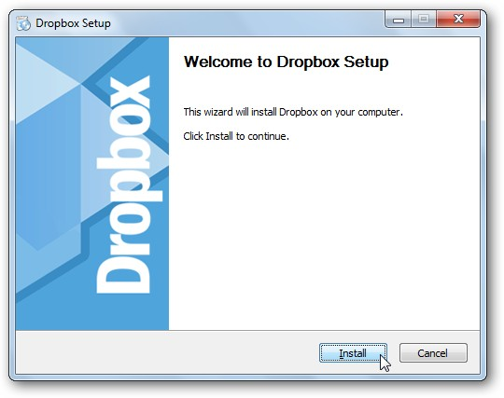Dropbox is a software used to store our data both in our PC and website. It is also functioned as a data back up when our PC is in trouble and cannot be accessed. To install *Dropbox* to your PC, *the first thing* that you should do is go to <https://www.dropbox.com/downloading> to get the installer. *Next*, click *Save File* button *then* wait until the download is complete. When the

download is complete, *then* run the installer. You will see the set-up wizard and begin the installation process by clicking Install button.